

Dr. Jennifer, Wilson inc.

2024-03-18

Dr. Wilson

151 John Glens Suite 904, South Angelaside, GU 18335

Phone: 3144620719

Fax: 6867556405

**Re:** Megan, Williams

**PHN:** 7100851168

**Birthdate:** 24-Aug-2005

**Address:** 2698 Anthony Knolls, Port Ashley, DE 05552

**Patient number:** 9197675231

To Whom It May Concern:

This is a medical letter to state the above patient is pregnant with expected delivery date of 29-Mar-2025. Hoping this information is satisfactory for your requirements.

Thank you.

Sincerely,

Dr. Jennifer, Wilson

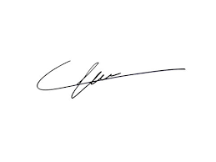

FRCS© NCMP

Clinical Assistant Professor, UBC

Department of Obstetrics and Gynecology SMH